Khangai Herds 6- A Day in the Life

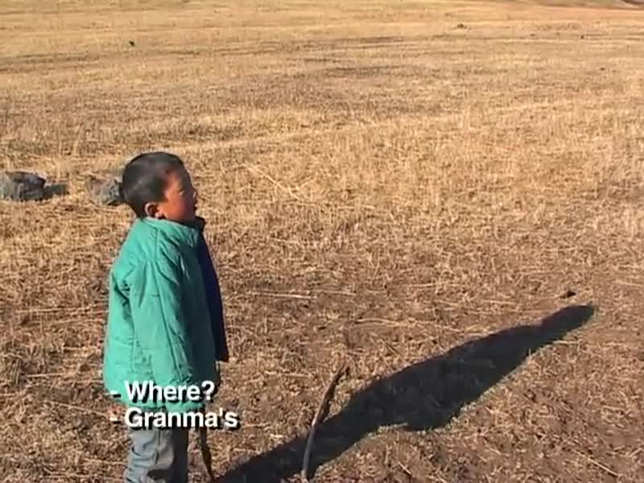

### identifier

1e7eb302-4eb5-4461-a30b-54fbd885755d

### creator

Fijn, Natasha

### type

Moving Image

### coverage

Mongolia

### description

This sixth segment of Khangai Herds features a day in the life of a Mongolian herding woman, who has ten children and twenty-six grandchildren. It is spring and she is caring full-time for a six month old grandchild but nurturing many newborn herd animals as well. She herds the sheep and goats with a couple of her grandchildren and discusses a wolf attack with a neighbouring herding woman.

### publisher

### source

<https://vimeo.com/14314275>

### rights

<https://creativecommons.org/licenses/by-nc-nd/3.0/>

### subject

Living with Herds

co-domestic

domestication

encampment

ethnography

family encampment

herding

human-animal

khangai herds

nomadic

nurturing animals

observational film

pastoralism

reciprocal

visual

wolf

### date

2010-08-21

### language

Mongolian

### format

video/mp4

### contributor

### original filename

Khangai Herds 6- A Day in the Life.mp4

### remote embed url

https://player.vimeo.com/video/14314275

### relation

### extent

64.0MiB

753.115000